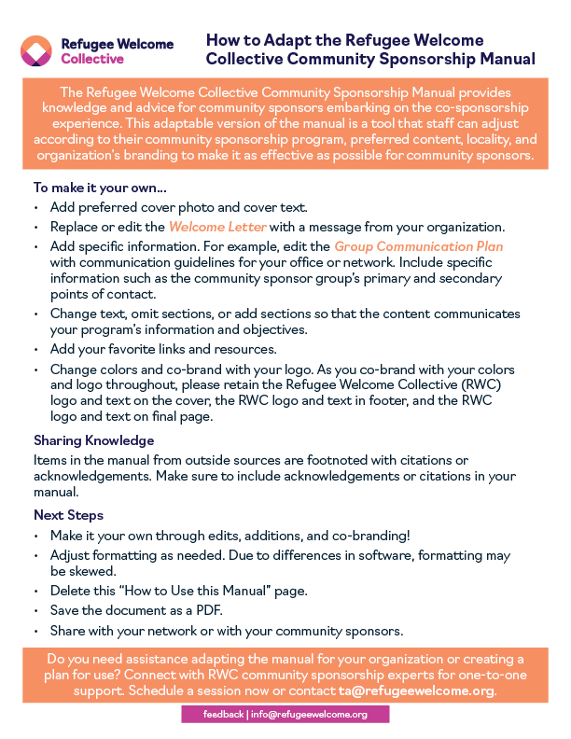

**Community Sponsorship Manual**

**Dear Community Sponsor,**

Thank you for your interest in community sponsorship. Through community sponsorship, a group of people work together to prepare for and to welcome refugee newcomers. As a community sponsor, you provide key services as well as in-kind or financial support during newcomers’ first months in the U.S. Most importantly, you provide a sense of belonging, welcome, and inclusion to newcomers — while building stronger communities.

We hope this guide provides knowledge and advice as you embark on this experience skillfully and thoughtfully. While this manual will not provide all the information you need, your local resettlement agency, fellow group members, community, and newcomer neighbors can provide helpful knowledge. Key sponsorship tools are also available at the end of this manual. The information and resources within this manual were created for community sponsors serving as co-sponsors in partnership with a local resettlement agency. While the information may be helpful to any community sponsor, please be mindful of any requirements or resources specific to your community sponsorship.



The newcomers you welcome were forced to leave home for an uncertain future in a new place. You will experience some fraction of this as you have signed up for the uncertainties of welcoming newcomers from a different place, a different community, and a different life experience. However, one certainty is that if you expect the unexpected, approach the experience with an open heart, and celebrate progress, you will form life-changing relationships and enduring memories.

Newcomers depend on you to provide encouragement, connection to the community, links to local resources, and an initial warm welcome. We invite you to depend on us for support, best practices, and appreciation through the community sponsorship experience.

We look forward to being part of your community sponsorship experience and the community- building impact it will have for years to come.

Sincerely,

# Contents

Refugees Overview 7

Shared Principles 9

Group Roles 11

Group Leader Role 13

Group Communication Plan 14

Community Sponsor Checklist 16

Education 18

Employment 21

Finance 23

Furniture, Clothing, and Food 24

Health 26

Housing 30

Cultural Orientation 33

Transportation 36

Fundraising 38

Community Sponsorship Tools 40

Referenced Resources 42

## Who is a Refugee?

A refugee is an individual who has fled their home country and cannot return due to a well- founded fear of persecution based on religion, race, nationality, political opinion, or membership in a particular social group.





*Race Religion Nationality Political*

*Opinion*

*Membership in a Social Group*

By the end of 2022, the number of refugees under the mandate of the United Nations High Commissioner for Refugees (UNHCR) had surpassed 29 million.1 According to available demographic data, over 70 percent of refugees came from five countries: Syria (6.8 million), Afghanistan (2.4 million), South Sudan (2.4 million), Myanmar (1.1 million), and the Democratic Republic of the Congo (900,000). The latest UNHCR figures indicate that the number of people who have fled Ukraine since the start of the war in 2022 has surpassed 6.8 million.

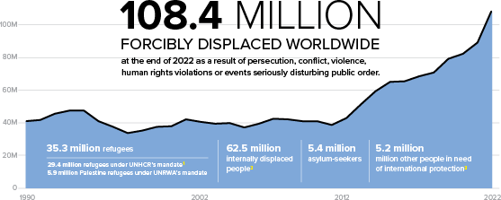

Image: UNHCR

Under the United Nations’ 1951 Convention Relating to the Status of Refugees2, eligibility for refugee protection requires a current or future fear of persecution. An individual may qualify for refugee status under the Convention’s terms only if they fear persecution on one or more of the five grounds listed above. An individual is not eligible for refugee protection if they have committed a crime against peace, a war crime, a crime against humanity, a serious non-political crime outside the country of refuge prior to their admission to the country of refuge, or is guilty of acts contrary to the purposes and principles of the United Nations. The resource below also provides helpful definitions.

[U.S. Immigration and Nationality Act Definitions](https://www.uscis.gov/laws/immigration-and-nationality-act) (USCIS.gov)

1. UNHCR. (2023). Global trends report 2022. UNHCR. unhcr.org/global-trends-report-2022
2. UNHCR. (2010). Convention and Protocol Relating to the Status of Refugees. UNHCR. unhcr.org/3b66c2aa10

## What can I learn about refugee groups coming to the U.S.?

The Cultural Orientation Resource Center (CORE) provides [backgrounders](https://coresourceexchange.org/refugee-populations/) on refugee groups, including refugees from Afghanistan, Bhutan, Burma, the Democratic Republic of Congo, Iraq, Syria, and Ukraine. The backgrounders provide general cultural, historical, and political information.

## How does refugee resettlement work in the U.S.?3

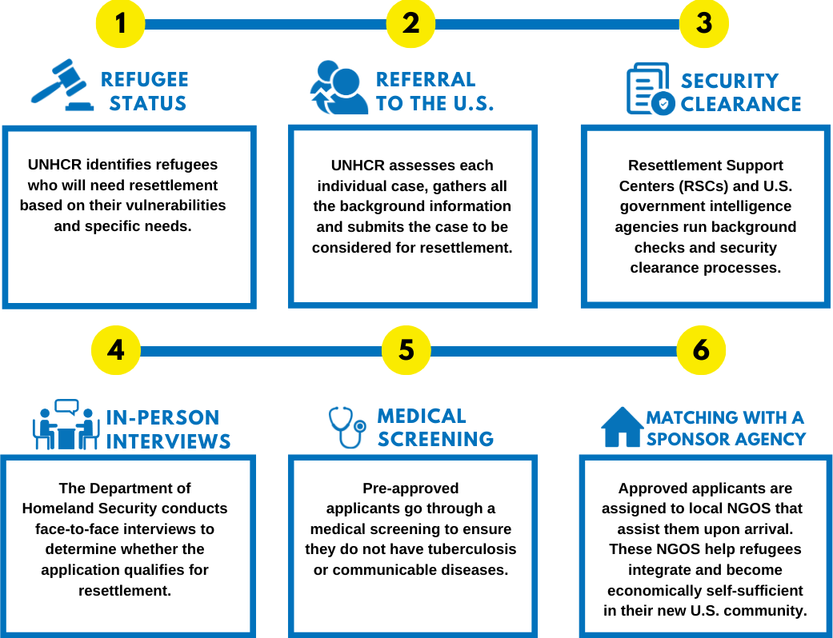

Image: USA for UNHCR

 [Refugee Facts: Refugees in America](https://www.unrefugees.org/refugee-facts/usa/) (UNrefugees.org)

 [The U.S. Refugee Resettlement Program Explained](https://www.unrefugees.org/news/the-us-refugee-resettlement-program-explained/) (UNrefugees.org)

[U.S. Refugee Admissions Program (USRAP) Flowchart](https://www.uscis.gov/sites/default/files/document/charts/USRAP_FlowChart.pdf) (USCIS.gov)

1. USA for UNHCR. (2022). How does the resettlement process work in the U.S.? The U.S. Refugee Resettlement Program Explained. Retrieved from [unrefugees.org/news/the-us-refugee-resettlement-program-explained](https://www.unrefugees.org/news/the-us-refugee-resettlement-program-explained).

The role of community sponsor is unique to other roles you may have filled in other areas of life. The role is unlike that of a parent, friend, or legal sponsor. A community sponsor accompanies refugee newcomers during the sponsorship period, connecting them to initial resources, and facilitating linkages for ongoing integration. The below shared principles can guide sponsors in fulfilling their role. Further, by coming together and acting according to shared principles, groups are likely to achieve the goals of sponsorship.

## Respect Newcomer Autonomy

Newcomers are fully autonomous human beings. They possess the resilience, strength, and potential to set goals and address challenges in their resettlement. It can be easy to lose sight of this autonomy and resilience because newcomers arrive in a vulnerable position having experienced challenging and harrowing circumstances. However, respecting a newcomer’s autonomy means recognizing that the newcomer is the best person responsible for making their own life choices. Therefore, a community sponsor should enjoy collaborating with others and approach challenges with patience and curiosity.

## Promote Self-Sufficiency and the Strengths-Based Approach

One key focus of sponsorship is to reinforce

newcomer strengths and to facilitate skill-building for self-sufficiency. Taking a strengths-based approach means assuming individuals possess the skills, knowledge, connections, and capacity for

### In essence, sponsors should think not of “doing for” the newcomer, but rather “doing with” the newcomer.

growth to meet challenges. In a strengths-based approach newcomers’ strengths, efforts, and progress is centered and praised. Successes, big and small, are celebrated along the course of the sponsorship. Emphasis is placed on how sponsors can support the newcomers’ desired outcomes and goals. Newcomers lead on setting and prioritizing their own goals. In promoting self-sufficiency, sponsors should think not of “doing for” the newcomer, but rather “doing with” the newcomer. To be responsible collaborators in reaching self-sufficiency, sponsors can be intentional about providing skill-building opportunities, be proactive in providing opportunities for community connection, and provide information without making decisions for the newcomer.

## Practice Cultural Humility

Cultural humility is a vital perspective while working with newcomers. The National Institute of Health defines cultural humility as a “process of self-reflection and self-critique whereby the individual not only learns about another’s culture, but one starts with an examination of her/his/[their] own beliefs and cultural identities.”4 In other words, culturally humble sponsors engage in self-reflection, value flexibility, and responsiveness, and ensure differences are valued.

### Taking a strengths-based approach means to assume individuals possess the skills, knowledge, connections, and capacity for growth to meet challenges they experience.

From the perspective of cultural humility, the newcomer is the teacher. Cultural humility discourages acting out of assumptions, recognizing not everyone in the same culture group will share the same characteristics or beliefs.

One way to think about cultural humility is that when differences arise, you think not only about the culture of the newcomer but think about your own values and experiences. In cultural humility, there is no assumption of right or wrong, only differences to be approached with respect and curiosity.

1. Tervalon M, Murray-Garcia J. Cultural humility versus cultural competence: A critical distinction in defining physician training outcomes in multicultural education. Journal of Health Care for the Poor and Underserved. 1998; 9(2):117–125.

## Focus on Integration

The United Nations High Commissioner for Refugees (UNHCR) defines integration as, “a dynamic two- way process that places demands on both the refugee and the receiving community. Integrating refugees goes beyond ensuring that they are provided with basic needs and access to services. . . [It includes] fostering a sense of belonging and encouraging participation in their new communities.”5 Sponsors can be key in initiating an early sense of belonging and facilitating community participation. As integration is an ongoing process continuing long after the sponsorship period, one of the primary roles of a sponsor is to connect newcomers to others in the community and find ways for them to connect to others in their cultural communities. These connections situate newcomers for integration long after the sponsorship period concludes.

Newcomers come from cultures with different systems

and traditions. The newcomer may make some adjustments to their lifestyle, so they are adhering to new laws and established best practices in certain systems, but integration does not require newcomers to give up their culture or history. It is important to respect their culture and traditions and find ways for them to stay connected to their culture and traditions in their new country.

## Incorporate Trauma-Informed Care

Sponsors do not need to know the specifics of a newcomer’s trauma or have a clinical background to incorporate principles of trauma-informed care (TIC) into their support. TIC is not a specific therapy meant to treat symptoms directly related to an individual’s past trauma. Instead, it is an approach to providing support in a way that is appropriately responsive to an individual who has experienced trauma while minimizing opportunities for re-traumatization.

The following are the principles of trauma-informed care6 :

### UNHCR defines integration as, “a dynamic two-way process that places demands on both the refugee and the receiving community. Integrating refugees goes beyond ensuring that they are provided with basic needs and access to services . . . [It includes] fostering a sense of belonging, and encouraging participation in their new communities.”

* **Safety**: Find ways, big and small, to create a sense of both physical and emotional safety.
* **Trustworthiness**: Try to avoid making promises you cannot keep, set and enforce clear boundaries, and communicate as simply and clearly as possible.
* **Choice**: Find ways, big and small, to incorporate choices into interactions with newcomers. Be sure to avoid making choices for them, but instead, provide clear information so newcomers can make choices for their own lives.
* **Collaboration**: Affirm the newcomer’s power and responsibility in their resettlement process. Be mindful of the inherent power imbalance that can be present in a sponsor-newcomer dynamics when sponsors have more knowledge of the new culture and access to resources.
* **Empowerment**: Remember the goal of resettlement is integration and self-sufficiency. Try and focus on reinforcing strengths and skill building in all your service delivery and interactions with the newcomer.

1. United Nations High Commissioner for Refugees. (2013). Integration of resettled refugees: Essentials for establishing a Resettlement Programme and Fundamentals for Sustainable Resettlement Programmes. UNHCR. Retrieved February 16, 2023, from [unhcr.org/protection/](http://www.unhcr.org/protection/resettlement) [resettlement](http://www.unhcr.org/protection/resettlement)
2. University at Buffalo. (2022, October 24). *What is trauma-informed care?* University at Buffalo School of Social Work - University at Buffalo. Retrieved February 16, 2023, from socialwork.buffalo.edu/social-research/institutes-centers/institute-on-trauma-and-trauma-informed-care

Community sponsorship is an experience in teamwork and collaboration. Given the array of welcoming activities a group takes on, it can be helpful to organize your group members into specific focus areas and roles. In addition to a group leader, having specific people or teams focusing on key areas such as housing and transportation ensures all-around support for newcomers and lessens the likelihood of confusion and group member burn-out.

The below introduces common roles and focus areas in sponsorship groups, as well as associated knowledge and skills so that you can organize your group. However, no two community sponsorship groups are exactly alike. Group roles or focus areas can be adjusted according to the unique goals of the newcomers and the capabilities and interests of group members.

## Group Leader

The group leader or co-leader’s role is to use collaborative leadership skills and to delegate work to other group members. The group leader maintains clear, thorough, and open communication between the resettlement office staff and the community sponsor group. They set boundaries, model patience and respect, communicate effectively, and solve problems. The group leader is often the main point of communication between the community sponsor group and resettlement staff. They provide oversight for background checks, paperwork compliance, and financial accountability. A group leader:

* + Enjoys collaborating with others.
  + Approaches challenges with patience and curiosity.

## Housing

The housing team works with resettlement staff to make identified housing a welcoming home. They may also help with the housing search. They often collect furniture and household items, stock the kitchen, and provide a culturally appropriate welcome meal. They may also offer assistance and guidance for apartment home living. The housing team has:

* + Ability to find and mobilize donations of furniture and household supplies including pickup, storage, and delivery.
  + Interest in discovering foods from other countries.
  + Interest in setting up a new home.

## Transportation

### “We all focused on areas where we thought we could provide the greatest value-added, and we tried to be flexible on who did what and when depending on schedules. I think this not only benefited the family, but also helped to maintain a cohesive and functioning sponsorship group.”

— Mark, community sponsor

This team supports family transportation and community navigation needs, especially in the early days after arrival. This team arranges transportation for airport arrival, initial healthcare appointments, grocery shopping trips, or for public benefits appointments. Most importantly, they provide public transportation orientation, accompanying individuals to key locations on public transit. The transportation team has:

* + Knowledge of community’s public transit or interest in exploring.
  + Some team members with access to their own car for initial appointments and tasks.
  + Varied availability within team with some availability for weekday appointments.

## Health

The health team supports health and mental health needs in active collaboration with resettlement office staff. In coordination with the transportation team, they will assist the family in attending any initial health screening appointments. They support the family in setting up a calendar for healthcare appointments and making initial contacts. The health team introduces individuals to healthcare resources including the

nearest hospital, pharmacy, urgent care, and local mental health services or refugee-related support groups. The health team has:

* + Knowledge of community health care resources or interest in exploring.
  + Varied availability within team with some availability for weekday appointments.

## Education

This team helps families access English learning programs and supports their knowledge and comfort with communication. This may include helping with sign-up for local English learning programs. Team members may practice English conversation with individuals and connect them with resources such as the local library, picture or bilingual dictionaries, and translation apps. This team may also assist families with children with school enrollment and orientation to the K-12 school system. The education team has:

* + Experience in education or the K-12 school system.
  + Interest in researching language learning opportunities and resources.
  + Attitude of patience and fun for English language practice.
  + Enthusiasm to learn a few new words in a new language.

## Employment

This team supports employable individuals in looking for and securing safe and dignified employment. Once employment is secured, they may assist with practicing public transportation and ensuring refugees have necessary clothing or supplies for their work. The employment team has:

* + Interest in exploring local employment opportunities.
  + Willingness to help practice job transportation and job-specific skills.

## Finance

The finance team applies their knowledge of personal finances and budgeting. Important tasks may include setting up a bank account and supporting the family in using SNAP benefits or other public benefits cards. The finance team has:

* + Interest in budgeting and personal finance.
  + Basic experience paying your own bills.

## Orientation

This team supports the newcomers in acquiring the needed knowledge, skill, and attitudes for life in the

U.S. They will help them orient themselves to their new hometown. They will locate and map the nearest grocery store, library, park, laundromat, bank etc. If the family is of a certain faith tradition, they may help connect them with their preferred community of faith such as an area mosque, church, or temple. They, and other teams, will connect family with relevant resources available to refugees through the Cultural Orientation Resource Exchange. The orientation team:

* + Likes to visit local community spots — and share them.
  + Is curious to find local resources and experiences that align with family’s interests and goals.

Community sponsorship groups provide more effective support to newcomers by organizing their group thoughtfully. While group members coach and help with specific resettlement tasks within their focus area, all group members provide social and emotional support to the newly arrived family. To those who have been through loss and displacement, this social and emotional support from the whole group provides welcome, inclusion, and belonging.

The community sponsorship group leader or co-leaders’ focus is to delegate tasks among the group and maintain open communication. Some key roles the group leader plays in support of the group and newcomers include:

## Communication Hub

Perhaps the group leader’s most important role is to be the primary point of communication. The group leader communicates information between resettlement staff and sponsor group committee leads or the entire group. They may establish a shared calendar where staff and sponsor group members can see scheduled appointments and other important dates. They confirm delivery of services and in-kind donated items through the [RWC App](https://refugeewelcome.org/welcome-collective-app/), email, case notes, or other logs and forms.

## Meeting Scheduler

The group leader coordinates and helps set regular meetings with the entire group, setting agendas and making sure all are informed. They may also meet with committees as needed. As requested, the group leader may meet regularly with agency staff to report progress, ask questions, and identify action items or next steps.

## Paperwork Champion

### “A good group leader is organized, has the ability to use others’ talents and let them take the credit, and has a good sense of humor.”

— Flicka, community sponsorship

group leader

The group leader is ultimately responsible for all necessary paperwork. They are likely to sign the form establishing a formal agreement between the local resettlement office and the sponsorship group. They may also ensure that all funds raised by the group are documented. The group leader makes sure each member of the group has completed a background check and has participated in training. They are responsible for making sure service delivery activities such as English language training enrollment or school registration are completed on time and appropriately documented. They work with the group to ensure case notes are recorded.

## Problem Solver

The group leader is a problem solver. When issues of concern are raised by resettlement staff, group members, or newcomers; the group leader makes their best effort to address those concerns with everyone involved. For example, if staff has brought up concerns about client dependency and self-sufficiency goals, the group leader could reiterate the importance of skill building with the group and help make specific plans for encouraging newcomers to meet specific self-sufficiency goals. Likewise, if clients or group members have raised concerns about delays in Employment Authorization Documentation delivery and its effect on employment possibilities, the group leader should reach out to the local office staff contact person to inquire about the delay status and possible next steps or follow-ups until completion of the task.

## Supporter of Principles

The group leader works to incorporate the principles and practices of a skilled community sponsor in the group’s work. The group leader practices setting positive boundaries and models patience and respect in sponsorship support. They receive continued guidance regarding shared principles of cultural humility, respect for client agency, and a focus on empowerment and self-sufficiency.

Effective community sponsor group communication is at the heart of successful sponsorship. Communication and relationships within the group can be as rewarding and important as those with the newcomer you are welcoming.

The following are communication best practices for sponsor groups:

* Select a routine time to have the entire group come together to discuss updates, ask questions, and share relevant information.
* At the start of a sponsorship, meetings will need to happen more frequently. Once per week, either in person or over a platform like Zoom, may be sufficient. Meeting frequency may decrease over the course of the sponsorship.
* There can be almost daily changes and moving pieces at the start of a sponsorship. For non-urgent items, all group members should try and save questions and updates for the meeting time.
* Groups should incorporate the use of any calendars, timelines, and case plans in their planning and communication.

### “I advise sponsors to approach any conflict with curiosity. It’s hard to be angry or frustrated when you’re curious.”

— Minda, community sponsorship staff

* Group leaders can work with resettlement agency staff to determine:
  + staff primary point of contact for co-sponsor group leader
  + staff point of contact ‘s preference for phone, email, or text communication and expected response time (staff are often working with many newcomers and sponsors)
  + any regular meetings or check-ins for sponsors and staff point of contact
  + how the newcomer can escalate concerns, if any, to staff directly
  + how the sponsors can escalate concerns, if any, to staff
* All group communication and planning should prioritize newcomer autonomy and promote a strengths-based approach.
* The RWC App is a great tool to help sponsor groups stay on track with their key activities, and deadlines, and track progress across the team. While groups do not communicate directly in the app, they can view their team’s progress in completing core services and timelines for key activities. Learn more about the [RWC App](https://refugeewelcome.org/welcome-collective-app/) from your local agency.
* Conflict and differences arise in any group. At an initial meeting, decide on a few group guidelines for when differences arise.

## Sample Meeting Agenda

##### Date:

**Group Leader Updates**

*Group leader shares updates, including any updates from resettlement agency staff.*

##### Team Updates

*Individual group members or committees share updates, referencing case plan or timelines as applicable.*

##### Case Note Reminder

*Group leader reminds group members to track actions using case notes or other agency required documentation tools.*

##### Next Steps

*The group leader guides the group members in creating the next steps using the case plan or timeline. This should include both assigning actions to committees or individuals and planning on any shared calendars.*

##### Questions, Joys, and Concerns

*The group leader opens the floor for questions, joys, and concerns. Group leader notes any items that should be taken to the resettlement office staff.*

*A note taker can provide notes to group members within 24 hours of meeting, including both group members attending and group members unable to attend.*

## Team Communication, Confidentiality, Privacy, and Safeguarding

In doing some sponsorship tasks, you may have access to newcomer’s stories or personal information, while still being a relative stranger. Remember to take the following steps in team communication:

|  |  |
| --- | --- |
| **DO** | **DO NOT** |
| * Include all important, non-sensitive information in case notes such as dates, people present, and source of interpretation or translation. * When unsure if private or sensitive newcomer information or stories are to be shared with the group, do consult with the newcomers themselves or with the resettlement office staff. * Understand that an agreement of confidentiality does not prevent you from sharing safety concerns such as child or elder neglect or abuse or following any state mandatory reporting laws. | X Include sensitive information such as social security numbers in team communication.  X Include sensitive health information in team communication.  X Whether it is was shared with you by the newcomer or you observed it, do not share private or sensitive personal newcomer information or stories with the group. |

## Effective Communication and Healthy Group Dynamics

Sponsorship is a big commitment, and the process of resettlement can be a stressful one with complicated emotions. The beauty of doing this work as a group is relying on one another for support and accountability. Encourage open communication within your group. Be honest about any difficult feelings or even biases that may come up for you. Likewise, support one another by providing both encouragement and reminders about principles like cultural humility and the goal of self-sufficiency. Remember to communicate with curiosity and respect when conflicts or differences arise. To provide the best welcome possible for a newcomer, this healthy communication within the group is vital.

The community sponsor checklist is a week-by-week guide to the important activities sponsors and newcomer refugees can do together. Work with the newcomer and resettlement office staff to identify priorities and additional activities.

|  |  |
| --- | --- |
| **PRE-ARRIVAL** | * Organize the community sponsorship team * Complete training and community sponsorship paperwork * Fundraise for community sponsorship * Set up household including furniture, household goods, and food * Airport pick-up |
| **ARRIVAL** | * Arrival, home, and personal safety orientation in coordination with resettlement staff * Provide arrival meal that is appropriate for newcomers’ culture |
| **WEEK 1** | * Arrival meeting to discuss goals of sponsorship and calendar of activities * Review home and personal safety orientation * Documentation and enrollment in any applicable key benefits in coordination with resettlement staff such as:   + Employment Authorization Document (EAD)   + Social Security Card   - I-94  - AR-11   * + Medicaid   + Refugee Medical Assistance (RMA)   + Refugee Cash Assistance (RCA)   + Temporary Assistance for Needy Families (TANF)   + Supplemental Nutrition Assistance Program (SNAP)   + Women Infants and Children (WIC)   + Supplemental Security Income (SSI) * Grocery shopping * Clothing and necessities shopping * Community and cultural orientation |
| **WEEK 2** | * Budgeting, completing an initial monthly budget with newcomers * School enrollment for any school-age newcomers * Enrollment in English language training classes or programs * Transport newcomers to Refugee Health Assessment * Assist as needed in enrollment in employment services and connect with employers in coordination with resettlement staff * Review the lease with newcomers as applicable * Community and cultural orientation |

|  |  |
| --- | --- |
| **WEEK 3** | * Complete Selective Service registration with males ages 18 through 25 * Public transit orientation and practice * Community and cultural orientation |
| **WEEK 4** | * Identify health care and mental health providers and resources * Community and cultural orientation |
| **WEEKS 5 – 8** | * Budgeting, completing a monthly budget with newcomers * Assist newcomers in setting up a bank account * Follow-up health care appointments * Assist in completing employment applications in coordination with resettlement staff * Community and cultural orientation |
| **WEEKS 9 – 12** | * Midpoint meeting to review progress made and priorities for the last month of the sponsorship period * Budgeting, completing a monthly budget with newcomers * Assist in completing employment applications in coordination with resettlement staff * Community and cultural orientation |
| **WEEK 12** | * Transition meeting to review progress made, highlighting ongoing resources, and determining the nature and duration of any remaining support * A neighbor celebration gathering sponsors and newcomers to celebrate three months of sponsor period and future as neighbors7 |

1. Acknowledgement: This checklist incorporates content and expertise from [Church World Service](https://cwsglobal.org/).

## English Language Training

English language skills can open additional opportunities for newcomers in connecting with neighbors, employers, and information. Sponsors can assist newcomers by connecting them to the variety of resources available to help people learn English. Here are some of the common resources to explore:

* **Adult Education Programs**: Many community colleges and adult education centers offer English as a Second Language (ESL) courses that are designed for adult learners. These courses are typically available at various levels, from beginner to advanced, and often cover a range of skills, including reading, writing, listening, and speaking.
* **Community Programs**: Community programs, such as faith communities or community centers, often offer ESL classes or conversation groups to help people practice their English in a supportive environment.
* **Online Resources**: There are a variety of online resources available to help people learn English. Some of these online resources include:

 [BBC Learning English](https://www.bbc.co.uk/learningenglish/) (BBC.co.uk)  [Busuu](https://www.busuu.com/en).com

 [Duolingo](http://www.duolingo.com/).com

* **Libraries**: Many public libraries offer resources for people learning English, including books, audiobooks, online resources, and classes.
* **Volunteer Programs**: There are a number of volunteer programs that provide free tutoring or conversation practice for people learning English. Many local literacy councils provide free, one-on-one English tutoring. The [National Literary Directory](http://www.nld.org/) can be used to find literacy councils within your area.
* **Conversation sessions with sponsors**: One-to-one conversation is a great way for newcomers to learn and practice English. Sponsors play an important role in helping the family they are paired with to learn English. Conversation sessions can be formal or informal depending on the family needs and skill and comfort level of sponsor group members.

Keep in mind that it often takes a year to five years or more to develop fluency in another language, well beyond the sponsor period. A good goal for sponsors is to assist newcomers with the key phrases they need in their daily life to make a purchase at the grocery store or to ride the bus – and to connect them to the above opportunities for continued language learning.

## Continuing Education

Newcomers may have an interest in continuing higher education, specific technical education programs, skills, or certifications. Initial activities of employment or English language training often prevent newcomers from pursuing continuing education during the sponsor period. However, sponsors may help newcomers learn about community opportunities that align with their goals and initial steps and contacts to pursue those goals in the future.

## School Enrollment

Families with school-aged children need to be prepared with necessary documents, supported, encouraged to ask questions and to take advantage of available resources to ensure a smooth transition to a new K-12 school environment. The below table outlines common steps parents and guardians will need to take and tips for how you can support them in your sponsor role.

**School Enrollment Steps and Sponsor Role**

|  |  |
| --- | --- |
| **1**  **Gather**  **necessary documents** | Parents or guardians will need to gather all necessary documents to enroll the child, such as a birth certificate or passport, immunization records, proof of residency, and previous school records if available.  **Sponsor role: let the family know what documents will likely be needed and consider and discuss alternatives for documents they may not have. Be prepared for ways the family can translate documents if needed.** |
| **2**  **Choose a school** | Parents or guardians should identify the school district and school the child will attend, often based on the family’s address. They should also research the school’s programs, curriculum, and policies to ensure they meet the family’s needs.  **Sponsor role: offer to look at a map of your community together and explain the district system. You can also set aside time to view school websites together.** |
| **3**  **Schedule an**  **appointment** | Parents or guardians should contact the school or school district to schedule an appointment for enrollment. Some schools may require an appointment for enrollment, while others may allow walk-ins.  **Sponsor role: work with the family to find out if an interpreter will be available as needed.** |
| **4**  **Meet with the school** | Parents or guardians will meet with staff to complete the enrollment process. This may include completing enrollment forms, providing necessary documents, and discussing any special needs or accommodations the child may require.  **Sponsor role: prepare the parent or guardian with questions they might consider asking during their meeting. Support them in preparing other questions or concerns they have and may want to discuss at an initial registration phase. Be mindful of supporting the newcomer’s role as a parent. Make sure the parent carries important paperwork and forms and that parents or guardians are primary contacts.** |
| **5**  **Access**  **additional resources** | Schools may offer additional resources for newcomer students, such as language support, after-school programs, and counseling services. Parents or guardians should inquire about these resources and take advantage of them as needed.  **Sponsor role: encourage the parent or guardian to see what the school offers by visiting their website and preparing to ask questions at meetings with the school. Learn about the interests and needs of the child.** |
| **6**  **Attend orientation** | Parents or guardians may attend a school orientation or meet with the child’s teacher to learn about the school’s policies, programs, and expectations. This is also an opportunity to meet other families and ask any questions about the school or the enrollment process.  **Sponsor role: support the parents or guardians to feel comfortable to ask questions they have. This can be done by preparing questions ahead of time and supporting them to confirm an interpreter can be present.** |

Sponsors can help to prepare the parent or guardian to ask questions that are important to them and their family. Remember the school and staff should communicate with the parent or guardian, not the sponsor. The school should be willing to answer any questions and provide information to help newcomers make informed decisions about enrollment.

Questions families may ask when enrolling their children in school:

* What are the school hours?
* What is the daily schedule like?
* What extracurricular activities are available, such as clubs, sports, and music programs?
* Are there any specific requirements for uniforms or dress codes?
* What is the school’s policy on homework, grading, and testing?
* Are there any special programs or services available for students who need extra support, such as English language learners, students with disabilities, or gifted students?
* What is the policy on student behavior and discipline?
* What are the consequences for violating school rules?
* How does the school communicate with parents and families?
* What resources are available for parent involvement?
* Are there any fees or costs associated with attending the school, such as textbooks, technology, or extracurricular activities?
* How can the family stay informed about their child’s progress, including grades, attendance, and behavior?
* What is the best way to track key dates such as vacations, parent-teacher conferences, snow days, or other school events?

Employment is an opportunity for newcomers to achieve financial security, stability, and connection to their community. These benefits, as well as the need for income, make employment a priority for community sponsors and newcomers alike.

## Initial Job Search

Sponsors can begin the job search even before newcomer arrival by noting some of the employment opportunities available in their locality, especially those that might be a good opportunity for English language learners. Do an inventory with your group and a wider network for available jobs. Personal relationships and connections with employers are more likely to lead to an interview than online applications. Sponsors and newcomers can investigate opportunities listed on websites such as [Indeed.com](http://www.indeed.com/) or [Craigslist.com](https://geo.craigslist.org/iso/us). Many cities also have [CareerOneStop](https://www.careeronestop.org/LocalHelp/AmericanJobCenters/find-american-job-centers.aspx) job centers that may have listings of job opportunities.

## Application Support

In addition to assisting with online job search and application, you can walk with the newcomer to any possible employment locations convenient to the newcomer’s home. You can then inquire about job opportunities. If the jobs request resumes, you can assist the newcomer in designing one. If the newcomer has no formal work history, help them think of transferable skills by asking if they took care of children, spent time sewing, or coached youth in a sport. Sponsors will find these resources helpful:

 [10 Resume Tips for Getting a Job in the U.S. (USAHello.org)](https://usahello.org/work/find-a-job/resume-tips/#templates)  [Resume Review Checklist (UpwardlyGlobal.org)](https://jobversity.upwardlyglobal.org/wp-content/uploads/2018/10/Resume-Review-Checklist.pdf)

## Documentation

Refugees are fully authorized to work from their arrival in the U.S. They can demonstrate this by completing an I-9 form even before they receive an Employment Authorization Document (EAD) or social security card. The form I-94 is proof of work authorization. See also these resources:

[I am a refugee or asylee . . . How do I show my employer that](https://www.uscis.gov/sites/default/files/document/guides/D2en.pdf)  [I am authorized to work in the U.S.? (USCIS.gov)](https://www.uscis.gov/sites/default/files/document/guides/D2en.pdf)

 [Employment Authorization Documents (SwitchboardTA.org)](https://switchboardta.org/wp-content/uploads/2021/02/Updated-Switchboard-Toolkit-Work-Authorization-Documents.pdf)

## Interview Support

You can ask the newcomer if they would like help preparing for a job interview. If yes, you can focus on practices such as smiling and good interview dress. You can practice key phrases like “Thank you for the interview” or “I see this job as an opportunity to contribute.” Offer to do a practice interview if they would like.

## Job Support

Once a newcomer has found their first job, offer essential job support. This can be going with them to purchase work clothing, supplies, backpack for bus trip, or lunch bags or water bottles. You may also want to practice the public transit ride from home to work and back. Write down the work address, phone, and the names of supervisors and co-workers. Talk about examples of good work etiquette in the U.S. such as showing up on time, letting a supervisor know if they have to miss work for an illness, and not using a cell phone while working. Make sure they know how to access their work schedule as sometimes they are posted at the work site and sometimes they are online. These supports can contribute to job success.

## Managing Expectations

If the initial job opportunities do not align with the newcomer’s skills or interests, discuss some of the benefits of initial employment such as earning income, achieving some stability, and having a positive reference for other work. It can be helpful to remind the newcomer that their first job will likely not be their last job.

## Future Employment

While most newcomers engage in an entry-level job upon arrival, sponsors can support newcomers’ plans and goals for future employment. If the newcomer has worked in a specific field, you may help them research recertification in the U.S. and applicable courses of study at schools, universities or community colleges. See if you can connect them with a community member in the same field that may be able to keep in touch with them in months and years to

### “Employment was important. But I had immediate priorities to take care of my sick husband and my seventh-grade child. However, I was working part- time to support my family.”

— Marthe, newcomer

come. This person can serve as a career mentor or coach after your sponsorship period has ended and as the newcomer pursues career goals. Upwardly Global works to support immigrants and refugees with international credentials to restart their careers in the U.S. You will find their [Career Coaching and Digital](https://www.upwardlyglobal.org/career-coaching/) [Resources](https://www.upwardlyglobal.org/career-coaching/) helpful.

In the first months after arrival, newcomers can learn a few keys to money management. Community sponsors help newcomers as they establish bank accounts, create their family budgets, and pay bills

## Providing Pocket Money

Upon arrival at the airport, newcomers are given appropriate pocket money. Usually, this is done by resettlement staff. However, sponsors can support this effort by providing a wallet or purse to help keep cash safe. They may also provide some cultural orientation regarding common costs of needed items, like food or clothes, in the U.S.

## Supplemental Nutrition Assistance Program Benefits Card

Once Supplemental Nutrition Assistance Program (SNAP) benefits, also known as food stamps, have been applied for and approved, newcomers will receive a SNAP benefits card in the mail. The card acts similarly to a debit card in that it needs to be activated before use and will require a PIN for purchases and to check balances. A SNAP benefits card can be used at nearly all grocery and convenience stores. Sponsors can help newcomers learn how to use their SNAP benefits card and check their balance. Check with your local farmer’s market for possible “double dollars” when using SNAP benefits to pay for local produce. A [SNAP](https://www.fns.usda.gov/snap/eligible-food-items) [website](https://www.fns.usda.gov/snap/eligible-food-items) can help educate clients about what eligible items can be purchased using SNAP benefits.

## Setting Up a Bank Account

An important milestone towards self-sufficiency is establishing a bank account. Sponsors can do some research ahead of time to determine which local banks have low- or no-cost checking accounts and are convenient to the newcomer’s home. Group members can go with the newcomer and act as an advocate during the process of opening a bank account. Clients should be encouraged to practice asking for an interpreter if needed. Most banks have access to a language line to provide interpretation services to potential customers. After the bank account is established, sponsors can help newcomers learn how to use their debit card, write a check, and keep track of their balance. Keep in mind that the goal is for newcomers to do these tasks on their own. It may be helpful to make a practice check together for reference, or have them write down key steps and logins.

## Paying Bills

It is important that newcomers understand how to pay their bills. Group members can help newcomers understand how to keep track of and pay all of their bills. This process may require several different procedures. For example, to pay rent, the client may need to understand how to write a check and mail it or drop it off for the landlord. Other bills such as electricity, gas, water, or trash may be paid via online bill

### “The banking system is so different. I had to learn about different accounts and making sure how to manage my income and expenses.”

— Hamid, newcomer

pay through an app on their phone connected to their bank account. Still, other bills like phone or internet may require payment over the phone or in person using a debit card. You may help newcomers make a checklist of monthly bills, or mark each payment on a calendar with a symbol reminding them of the method of payment.

## Family Budgeting and Cost-Saving Tips

Creating a family budget can help clients make informed decisions about spending their money. A budget is a tool to assist families as they navigate the real challenges of starting with entry-level job income. Sponsors can utilize resources such as the RWC [Monthly Budget Tool and Guidance](https://refugeewelcome.org/resources/monthly-budget-tool/) to help clients create a family budget. The family budget should be an accurate accounting of all incomes (such as earned wages, refugee cash assistance, TANF, SNAP, etc.) and expenses (such as rent, utilities, transportation, food, cell phone, internet, etc.). Group members can also encourage cost-saving ideas such as getting a rewards card from the grocery store and using coupons, shopping for clothes at used or low-cost clothing stores, cooking food instead of eating at restaurants, and thinking about free or budget-friendly activities like local parks.

## Furniture

Newcomers have left their possessions and homes behind. Providing furniture and household items is a tangible way to provide a comfortable and warm welcome. A skillful sponsor can bring together community donations while wisely using resources and time at the beginning of the sponsorship. These tips can help you.

* Avoid collecting donations too early. Let interested donors know you will share a sign-up list for donations a few months before the newcomers’ possible arrival. Using a sign-up list (using a tool like [Sign-up Genius](http://www.signupgenius.com/)) helps avoid duplicate or unsolicited donations. Managing duplicate donations can use initial group

energy and time that can be saved for future welcoming tasks.

* When dealing in the world of global migration, expect the unexpected. Let donors know that due to the nature of refugee resettlement, the newcomer’s arrival date may change. As they sign up to donate, ask them to understand that their flexibility is part of their gift! They should expect to store and deliver donations anywhere from one to six months.
* Instead of storing the donated items in one

### “My husband and I’s biggest contribution so far was preparing the rental home. We took responsibility for new beds, bedding, bath towels and mats, and the kitchen set-up for a family of six, including four children. We were able to use a tool like Sign-up Genius to select the items for which you’d take responsibility. Very easy — printed it and off I went to my favorite stores.”

— Karen, community sponsor

place until the family arrives, consider the “single move” strategy. This is a strategy where you ask donors to hold on to items in their homes or wait to purchase items until you have an arrival date. Let them know you will alert them when and where the donations are needed. One or two volunteers can also be identified to assist any donors unable to transport their items. This strategy avoids a “double move” and the need for storage space. A realtor’s lock box can be a helpful tool in arranging team members’ coordination of delivery. If you are storing the items in a single location, make sure the owner of the space understands the unpredictability of the effort and can provide storage space for up to six months if the newcomers’ arrival is delayed.

* While you are asking for furniture donations, use your furniture donation sign-up to ask the community to donate gift cards the newcomers can use. Newcomers are likely to have specific needs or want to select some of their own items.
* Refugee Welcome Collective’s [Home Supply Checklist](https://refugeewelcome.org/wp-content/uploads/2022/05/checklist_home-supply.pdf) can be used to keep track of essential home furniture and supply items.

## Clothing

While it is helpful to have essentials like winter coats or hats on-hand for arrival, it is best to facilitate newcomers selecting their own needed clothing with gift cards at an affordable store soon after arrival. This ensures newcomers have key items according to their size and preference. If they are interested, additional trips can be planned to thrift stores. Be mindful that second-hand clothes may not be customary in some cultures. You may want to explain that second-hand clothing is common in the U.S. — especially when someone is just starting a new home or has growing children. Newcomers can tell you if they are content with the clothing they have, or can purchase or would like more clothing through a thrift store or clothing drive.

## Food

Stocking the kitchen before arrival provides necessities for the newcomer for the first week. Use a suggested food list, such as RWC’s [Grocery Lists](https://refugeewelcome.org/wp-content/uploads/2022/05/grocery-list.pdf), according to the newcomers’ home country. Be mindful that different people have different food preferences and restrictions. For example, many Muslims only eat halal meat, and many Buddhists are vegetarian. You may research stores in your community where the newcomer can find food items they are accustomed to. In addition to stocking the kitchen, schedule a trip to the grocery store soon after arrival so the newcomers can select and purchase the food they prefer. You can provide them with gift cards so that they can complete purchases themselves. Accompany them the first few excursions or until they feel comfortable on their own.

Accessing healthcare is an important part of the resettlement process. The U.S. healthcare system can be difficult for newcomers to navigate. Your role as a sponsor is to provide general information about how healthcare works in the U.S. and help the newcomer gain confidence in their ability to receive the care they need. You do not need to know about newcomers’ health conditions to introduce them to the U.S. healthcare system. Instead, your role is to be the navigator and advocate.

## Refugee Health Screening

After arrival in the U.S., the newcomer will attend a refugee health screening at a public health department. Resettlement office staff have established connections with local refugee health screening clinics and are a helpful source for determining how to make the appointment. A refugee health screening is not the same as a physical or a typical new patient exam, although they share many of the same components. In many locations, screening clinics have formal avenues to share health information with primary care providers or resettlement office staff to ensure any health conditions receive appropriate follow-up.

## Primary Care

Another health service provided to newcomers during their initial resettlement is establishing a primary care provider. Check with resettlement agency staff for clinics with experience serving new arrivals. Overall, the goal is for new arrivals to eventually access healthcare independently, and thinking about the most convenient location for primary care can help them meet this goal. Some tips for scheduling the initial appointment include:

* If an interpreter is needed, let the clinic know when scheduling the appointment. In the U.S., interpretation at healthcare appointments is required by law.
* Let the newcomer know they should tell the provider when making their appointment if they have a preference for the gender of their provider.
* When making the appointment, help the newcomer check if their health insurance plan is accepted.

Preparing for initial primary care appointment

Once the newcomer has made an appointment, it may be helpful to have a conversation about what to expect. Providing some general information about the healthcare system as well as specifically preparing for the upcoming appointment can ease anxieties. The following tips may be helpful.

* Clarify the different health spaces available in the U.S.: primary care, specialist care, urgent care, emergency room, etc. Explain that the upcoming appointment is to establish care with a new provider who will likely be the newcomer’s main point of contact for receiving health services.
* Let the new arrival know that they should bring their ID, medical insurance card, and any overseas medical records to the appointment. Newcomers receive an Employment Authorization Document, including children, which includes a photo ID. If this has not been received, overseas identification can be used.
* Explain that it can sometimes take multiple appointments to address all medical concerns, and the newcomer may need to make a follow-up appointment.
* Make a transportation plan for the appointment and ensure the family understands this plan.
* Explaining healthcare confidentiality in a U.S. context can help ensure newcomers get the best possible care. An example explanation may be: “In the U.S., healthcare is private by law. No one can see your health records or learn about your health conditions without your written consent, including the government. Even though I helped make your medical appointment, I

am unable to ask about your health concerns. In the U.S., even close family members cannot see your health records or ask your doctor what you discussed at your appointment without your consent.”

* Your role as a sponsor is not to make medical decisions or give specific medical advice. Instead, any questions a newcomer has about their appointment, instructions a doctor gave them, how to take medication, etc., is a good opportunity to practice calling the doctor’s office together.

## Medical Insurance

Upon arrival in the U.S., all refugees qualify for medical insurance for at least their first eight months in the country through Medicaid. After eight months, coverage for refugees varies. It is important for newcomers to understand that health insurance in the U.S. is usually tied to employment, and once an adult in the household starts working, their health insurance coverage may change. Some tips for helping newcomers navigate medical insurance include:

* Ask a case manager for clarification on applicable health insurance guidelines. You do not need to be an expert on this topic but knowing whether to expect coverage to change will help prepare the newcomers.
* Dental and vision coverage is generally limited. This coverage may be only for emergencies. Free or lower-cost services for dental or vision may be an option.

## Pharmacies

Explaining the basic ways a pharmacy works can be an important piece in ensuring the newcomers can independently navigate all aspects of the healthcare system. Some tips for helping newcomers navigate medical insurance include:

* Help the family choose an accessible local pharmacy. Even if no one is currently prescribed medication, visiting a pharmacy together and having the newcomers note the name and location can ensure they know what pharmacy they prefer once the medication is prescribed.
* In a pharmacy visit, explain what an over-the-counter medication is and show the newcomer where to find these medications. Then, explain a prescription and show the newcomer where they would pick up a medication prescribed by a doctor.
* If a family member is prescribed a medication, ask

if they need help remembering when to take it. A pill organizer can be useful in cases where many medications are being prescribed.

* Ensure the newcomer understands how refills work. Help set up automated refills or let the newcomer know to call or visit the pharmacy once they are low on medication.

## Mental Health

### One of the most important ways you can support new arrivals in terms of mental health is to reinforce the message of patient confidentiality and that a medical provider can help refer them to any type of care they may need.

As in the U.S., mental health is stigmatized in other parts of the world, including many of the places newcomers come from. In some refugee experiences, diagnosis of a mental illness in their home country meant ostracization from family and friends, shame, and sometimes even government involvement. While many refugees may experience mental health symptoms, it is important to not assume that this is the case for the newcomer you are serving. As a sponsor, one of the most important ways you can support new arrivals in terms of mental health is to reinforce the message of patient confidentiality and that a medical provider

can help refer them to any type of care they may need. You may also play the role of helping connect a new arrival to mental health services if requested. Some tips for navigating this topic with newcomers include:

* If you notice concerning symptoms in a newcomer, speak to the local resettlement office staff about how to proceed. Case managers may have received additional training on how to approach this topic.
* Other than reinforcing messages around confidentiality, you can also familiarize yourself with mental health resources available to refugees around the U.S. For example, find mental health resources for immigrants and refugees at [USAHello](https://usahello.org/health/mental-health/help-and-services/).
* Give newcomers options for reaching out for help in times of crisis. This may include community or faith leaders, local organizations, friends or family, or medical professionals. Ask the resettlement staff you work with if there is a local crisis hotline they would recommend for new arrivals, or search for one in your area. If you identify a crisis line, call it and ask if they offer interpretation and ask about confidentiality. Then, give the family this information. You can approach this conversation by saying something like, “The resettlement period can be very challenging for families. This is a resource you can use if you need help with how you are feeling. Anyone can use this number if they are feeling angry, sad, overwhelmed, depressed, or anxious. You can call and ask for an interpreter and then talk to a professional.”
* If a newcomer does ask for assistance finding a mental health professional, consult with resettlement staff about the best options. Sometimes a newcomer may not want to receive services through an organization tied to their cultural community for fear of others discovering they are in counseling. Once you have options for services, discuss them with the new arrival to see what they prefer.



## Navigating Health Care Independently

Here are some tips for how you can support newcomers to successfully navigate their healthcare independently.



|  |  |
| --- | --- |
| **Determine the literacy of the family and**  **their preferred ways of keeping track of appointments** | If they can read and write in any language, using a template like the one on page 15 of CORE’s [Health and Hygiene Resource](https://coresourceexchange.org/wp-content/uploads/2019/09/Health-and-Hygiene.pdf) be useful as a main location for all health provider or pharmacy information. This can also include the nearest urgent care that accepts their insurance as well as the nearest hospital. A calendar may be useful for tracking appointments. |
| **Practice health activities with a newcomer** | This can include taking the bus together to an appointment and back home. Role play calling a doctor to schedule an appointment together. Practice calling a pharmacy or picking up a prescription. If the newcomer doesn’t need to make an appointment, practice by having them call the clinic, ask for an interpreter, and ask for the date and time of an upcoming appointment. |
| **Remind new arrivals of their health care rights in the U.S.** | Beyond confidentiality, this includes the right to interpretation at any medical clinic. The patient-to-doctor dynamic may have also been very different overseas. Explaining to newcomers that it’s okay and normal to ask the doctor questions or tell the doctor if they prefer a certain treatment can help build confidence. |
| **Create a note they can share with others** | As a newcomer is getting used to independently accessing services, they may be nervous about venturing out alone. If this is a concern, use the note function in the newcomer’s phone to write out their name, date of birth, and address. This note can also include information or ask a question. Then, the newcomer can show the text to whoever assists them at the clinic. An example text you may write:  *“Hi, my name is . I need a/an interpreter. I speak . I am here for an appointment.”*  If the newcomer prefers this in text or WhatsApp, you can text them instead.8 |



Before and after arrival, the community sponsorship group, often with extended community support, can ready a home from which newcomers will launch their life in the U.S. This home will be the point from which newcomers will gain employment, engage with neighbors, connect with their cultural communities, and pursue educational opportunities. Safe, secure, and affordable housing provides a sense of place and is an important base for integration.

## Keys to a Good Home

The group may assist in the task of identifying decent, safe, and sanitary housing that meets important requirements for a good home for a newcomer. The following are important things to look for in a new home:

🔑 Within walking distance or easy public transit trip to a grocery store and K-12 schools

🔑 Within easy public transit distance to shopping, medical care, and English language learning opportunities

🔑 Access to laundry

🔑 Affordable — ideally, the rent would be a third of the income for a family with adults working entry-level jobs

🔑 Close to any established local cultural communities

🔑 Landlord willing to lease to a newcomer

🔑 Number of bedrooms sufficient for family composition and in accordance with state law

## Home Search

Searching for housing in the U.S. is challenging with a nationwide shortage of affordable and available homes. Uncertain arrival dates and landlords’ unfamiliarity with the refugee resettlement process can make the housing search for newcomers particularly challenging. Before you begin, consult with the resettlement office staff. A home for the newcomer may already be identified and the group can focus on home set-up. Below are some useful tips:

 Use online search tools such as [AffordableHousing.org](https://www.affordablehousing.com/), [Apartments.com](https://www.apartments.com/), [Craiglist](https://geo.craigslist.org/iso/us), or [Zillow](https://www.zillow.com/).

 Reach out to your network using email or social media, share the basics of what is needed such as the number of bedrooms, access to public transit, and range of rent. See if any of your friends or neighbors have recommended apartment communities or rental homes. Let your network know you are looking for a formal rental opportunity that the newcomer could use for years to come rather than informal housing situations offered.

 Reach out to local real estate agents or offices, they are tuned in to the housing market and may be a good resource to find affordable housing.

 You may not initially know the number of individuals or the size of the family you will be welcoming. Start your search by collecting information for one- to three-bedroom homes.

## Questions to Ask a Landlord

The group may assist in the task of identifying decent, safe, and sanitary housing that meets important requirements for a good home for a newcomer. The following are important things to look for in a new home:

* What lease terms are available — yearly, six months?
* Newcomers do not arrive in this country with the typical documentation renters provide for screening purposes; however, the newcomers have I-94 cards, are authorized the work in the U.S., and will have social security numbers. May we provide you with this information instead?
* What is the cost of average rent and utilities? Are any utilities included in the rent?
* What amount is the security deposit?
* If a co-signor is required, when can the co-signor’s name be removed from the lease – upon the newcomer meeting income requirements or at the end of the lease term?
* Highly motivated to have a new home, newcomers often make reliable long-term residents. However, what, if any, are the break-lease fees or re-letting options in the lease?
* When is rent due and how do you prefer rent to be paid – check, online?
* If the property is within a Homeowner Association, what are the rules or restrictions?
* Is renter’s insurance required?
* Who do residents contact if there is a maintenance issue on the property?
* What is the limit to the number of people who can live at this property?

If you need support in your housing search or navigating landlord relationships, you can reach out to Refugee Housing Solutions (RHS). RHS is a capacity-building project funded by the Bureau of Population, Refugee, and Migration to support refugee access to housing. They also offer the following resources:

 [Landlord Toolkit](https://refugeehousing.org/resources/landlord-toolkit/) [(RefugeeHousing.org)](https://refugeehousing.org/resources/landlord-toolkit/)

 [Recruit & Retain Housing Providers Toolkit (RefugeeHousing.org)](https://refugeehousing.org/resources/housing-provider-recruitment-toolkit/)

## Home Safety Orientation

Experience and familiarity with U.S. apartment living vary according to the newcomer’s home culture and their individual experience. It is important to remember that newcomers may benefit from the explanation of the use of some household appliances and may be completely accustomed to others. Explain differences respectfully and ask about how they might do it in their country.

Newcomers will benefit from a basic orientation regarding housing and personal safety matters on the day of arrival or the next calendar day. Remember to provide newcomers with emergency contacts and emergency services (911) on the day of arrival as well as their own address and phone number. The below are useful resources for home safety orientation.

 [Housing Orientation](https://coresourceexchange.org/wp-content/uploads/2022/06/CO-Toolkit-for-Community-Partners-and-Sponsors_June-2022-2.pdf) [(COREsourceExchange.org)](https://coresourceexchange.org/wp-content/uploads/2022/06/CO-Toolkit-for-Community-Partners-and-Sponsors_June-2022-2.pdf)

 [Personal Safety Orientation (COREsourceExchange.org)](https://coresourceexchange.org/wp-content/uploads/2022/06/CO-Toolkit-for-Community-Partners-and-Sponsors_June-2022-2.pdf)

[Welcome to Your New Home (SwitchboardTA.org)](https://switchboardta.org/resource/welcome-new-home-illustrated-guide/)



## Reviewing an Apartment Lease

Understanding the contents of a lease situates newcomers for informed housing decisions — now and in the future. You can use a highlighter to mark these items in an extra copy of their lease, assisting the newcomer in transferring key dates to a calendar and key numbers to their phone. Set the times when a group member can work with the newcomer to make their first rental payment or practice making a maintenance request.

Important information in the lease to look at includes:

* Lease start and end date
* Rent amount, due date, method of payment, grace periods, and late charges
* Utilities included
* Contact for maintenance requests
* Process and dates to know to renew lease and process and dates to know to end lease, including break lease fees

 [Understanding Your Lease (COREsourceExchange.org)](https://coresourceexchange.org/wp-content/uploads/2022/06/CO-Toolkit-for-Community-Partners-and-Sponsors_June-2022-2.pdf)

## Future Housing

Some newcomers may find their initial apartment home is the ideal place to live for years to come as it provides the affordability, community, and location the family desires. If the newcomers are interested in other housing options, you can share resources with them before the sponsorship period ends. They can revisit these resources later in their resettlement or at the end of their lease independently or with the assistance of a friend or neighbor. Below are helpful resources:

* **U.S. Housing Programs**: Refugees are eligible for U.S. housing programs such as public housing or housing choice vouchers. Reach out to your Public Housing Authority with the contact information provided below to find out what opportunities are available in your community, average waitlist times, and steps to apply. If newcomers are interested, introduce them to the local Public Housing Authority for future opportunities. U.S. housing programs are usually not an option for initial housing due to waitlists and requirements.

 [Public Housing Agency Contact Information (HUD.gov)](https://www.hud.gov/program_offices/public_indian_housing/pha/contacts)

* **Financial literacy programs**: Certain financial literacy programs may be a good future resource for newcomers as some provide support to first-time home buyers.
* **Habitat for Humanity**: This or similar programs may provide support for home ownership.

Newcomers have been separated from their home communities, friends, and family. Sponsor groups can provide social support and support newcomers in establishing a feeling of home. Through Cultural Orientation, newcomers learn about the culture and context of their new neighbors.

## What is Cultural Orientation?

According to the Cultural Orientation Resource Exchange (CORE), refugees participate in a cultural orientation to acquire vital knowledge, skills, and attitudes needed to adapt to their new lives and achieve self-sufficiency. CORE focuses Cultural Orientation around the topics:

|  |  |
| --- | --- |
| * Budgeting and personal finance * Cultural adjustment * Digital technology * Education * Employment * English * Health and hygiene * Housing | * Newcomer rights and responsibilities * Public assistance * Role of the resettlement agency * Safety * Transportation * U.S. laws * Your new community |

## Cultural Orientation Resources

Newcomers can access content through CORE’s Settle In App. The Settle In App is a newcomer-facing mobile app with interactive chapters and gamification in multiple languages. Once downloaded, the app is available for offline use. This app can be downloaded from the App Store and Google Play.

Newcomers can also access CORE’s Settle In Website. This resource is a newcomer facing website with fact sheets, videos, and podcasts on a variety of Cultural Orientation topics translated into multiple languages and designed with newcomer literacy needs in mind. There is also a help center that provides more tailored content to specific populations.

 [Settle In](https://settleinus.org/) (SettleInUS.org)

CORE offers self-paced courses for sponsors on its learning platform. The Sponsorship Orientation pathway will guide you through multiple courses designed to teach you more about the resettlement process and best practices in teaching adult learners.

 [Online Courses & Webinars (COREsourceExchange.org)](https://coresourceexchange.org/cultural-orientation-certification-course/)

The Cultural Orientation Toolkit for Community Partners and Sponsors teaches sponsors how to incorporate cultural orientation messages as they complete services and activities in the first months after arrival.

[Cultural Orientation Toolkit for Community Partners & Sponsors](https://coresourceexchange.org/resources-for-community-partners-and-sponsors/) [(COREsourceExchange.org)](https://coresourceexchange.org/resources-for-community-partners-and-sponsors/)

Cultural Exchange Activities walk sponsors through self-reflection activities and outline five activities to support newcomers in feeling welcome, included, and celebrated.

[Cultural Exchange Activities (COREsourceExchange.org)](https://coresourceexchange.org/wp-content/uploads/2023/03/FINAL_Cultural-Exchange-Activities-2_24_23.pdf)

In the activity bank, sponsors can explore a variety of CORE’s activities, lesson plans, and additional resources for Cultural Orientation topics.

 [Activity Bank (COREsourceExchange.org)](https://coresourceexchange.org/activity-bank/)

## Community Exploration

Community sponsors can share what they love about their new community. This is an opportunity to explore the community in fun and educational excursions. Newcomers can learn about places and resources they can access long after the sponsor period, knowing that they can get there via public transportation.

## Social Activities

### “The older children of the family we sponsored really enjoyed gathering with other Afghans to play indoor soccer since it was the middle of winter. It felt familiar to them . . . Visiting the zoo was the biggest hit!”

— Brenda, community sponsor

Scheduling social activities with newcomers can help avoid isolation and loneliness. You may feel uncomfortable scheduling an activity that is not necessarily a sponsorship task. However, ask the newcomers if they would like to get together for a specific activity; get out of your comfort zone!

Possible social or community exploration activities

* Locate and map all the places the newcomers know such as the grocery store, park, laundromat, bank, etc.
* Go to the library, check out the resources, use a computer, etc.
* At the post office, practice mailing a letter or mailing a package to a friend, a member of the group, or the newcomer’s home.
* Visit the local park.
* Attend a sporting event.
* Go to a museum or the zoo.
* Track local free events and attend one together.
* Give a “Welcome to the Community” tour with local landmarks and places you can explore in the coming months.
* Celebrate a holiday together — whether a holiday in the U.S. or the newcomer’s home country.
* Play children’s games that may be similar in the U.S. and the newcomer’s home country such as tic tac toe, checkers, or other.

## Connecting with Cultural Communities

Connecting with other neighbors from their home country or their faith community is key to integration. These neighbors may be able to provide information and advice that is particularly helpful or insightful as newcomers navigate their new community. You may note that some newcomers may choose not to connect with their own cultural communities if they have experienced persecution, or discrimination, or are concerned about their safety for other reasons.

Possible activities for cultural community connection

* Ask the newcomers if they practice a particular faith. If yes, ask if they would like help locating the local church, mosque, temple, or other faith community.
* Visit local ethnic grocery stores or restaurants.
* Before and after arrival, see if there is anyone from the same country or language group in your extended network. Remember not to give anyone the names or contact information of the newcomers. Instead, ask if you can provide the more established resident’s name and contact to the newcomer family so that they can decide if they want to reach out.
* Ask the newcomer about their favorite music, newspapers, sporting events, TV shows, or radio programs. See if you can access these online or through another source.

From grocery shopping to medical appointments to a first job, transportation is a key thread in self-reliance and integration. Sponsors often accompany newcomers to their appointments in the initial days after arrival and assist them in the first weeks to get to points of interest, whether to and from work, places of worship, or English language training.

## Key Transportation Reminder

For the first days of helping the newcomers with transportation, keep in mind the key mindset of doing *with* rather than doing *for*, and to think about how they can become independent in this task without your assistance. The transportation committee supports the newcomers to achieve the goal of being able to get around on their own when they want or need to, and according to their budget. In the first few weeks, as appointments are made, be intentional about communicating with other group members about opportunities to empower the newcomers with getting to and from their destination without the assistance of a ride. For example, if the newcomers have just one appointment scheduled for the day, practice taking public transit to and from the appointment. Additionally, as the newcomers establish routines, such as going to English language training or work, consider accompanying them the first time to help them build the confidence to make the commute on their own.

## Airport Pick-Up

In some cases, sponsors may meet newcomers at the airport. After meeting the newcomer at the airport, transportation will need to be provided, unless transportation has been arranged by the resettlement agency staff or family of the newcomers that already live in the community.

## Providing Rides

Like many others in the community, the newcomers and your committee will primarily use public transit. However, there are times when driving the newcomers will be necessary. As your committee organizes for car transportation, consider:

* Which committee members have access to their own car for initial appointments and tasks?
* What is the availability within the committee for weekday appointments?
* Always ensure that committee members transporting newcomers have a valid driver’s license, vehicle insurance, and a background check.
* Recruit additional background-checked volunteers with vehicles if needed.
* Set up an organizational system such as a sign-up sheet for posting transportation needs and arranging rides.
* Plan for larger and younger families. For example, you may need two cars to transport large families. Refer to state car seat laws to determine what types of car seats are needed.
* Anticipate that most of the transportation with car rides happens right when the newcomers arrive.
* Arrange to arrive at the newcomers’ homes ahead of time to pick them up and transport them to any appointments.
* Be sure to keep good boundaries and respect newcomers’ privacy. For example, if arriving to pick up a newcomer and they do not answer the door, wait and call or text a few times. Do not enter their home unannounced.

## Public Transit

Before the newcomers arrive, transportation committee members should begin to familiarize themselves with the local transit system and prepare to provide orientation. When the newcomers arrive, practice taking public transit and empower them to use it on their own.

* Look into reduced fare programs and any other possible transportation benefits that might be available.
* When accompanying the newcomers on public transit, refer to the public safety recommendations of all relevant modes of transit (e.g., bus, metro, trains, and ferries) to ensure that the newcomers travel safely and are always aware of their surroundings.
* Equip the newcomers with the tools they will need to take trips on their own. For example, download a transit app on their smart phone to track metro and bus schedules in real-time, see fares, and more. Or, print out maps and schedules of relevant routes, including alternate routes.

## Other Ways of Getting Around

As you guide the newcomers in accessing available transportation in their new community, identify all the other ways they might travel, such as ridesharing, bike sharing, taxi, and walking, as well as how each option might be feasible depending on the types of appointments they might have and routines they might establish. Be sure to provide safety orientation for each mode of transportation, for example, wearing a safety helmet when riding a bicycle or sharing the itinerary of a ridesharing trip with a family member. As newcomers may use ridesharing apps such as Uber and Lyft for key

appointments, occasional trips, or emergencies, consider riding with them once or twice. However, be sure to discuss how ridesharing and taxis may be more expensive. Donated bikes, helmets, and locks might be helpful to newcomers but check with them as they may or may not be interested or have space to store them.

## Car Purchase and Driving

### “The home of the family was close to public transit, which they took to school and work. They have a car now. Our group provided some information, but a family friend helped them buy the car.”

— David, community sponsor

Questions about how to help newcomers access a car may come up within your sponsor group. The request for help buying a car may also come from newcomers. Often, sponsors are not able to assist with driving lessons and purchasing a car as these often fall outside the sponsorship period or car ownership is not within the newcomer’s budget. Assess newcomers’ interest in eventual car ownership. You can help by having a conversation about the various steps and expenses involved in purchasing and maintaining a vehicle, such as car insurance, registration fees, excise tax, annual inspection, maintenance, gas, and so forth. You can share information about driving schools, local car donation programs, and how to study for the driver’s permit test. Some sponsor group members may be able to assist with car purchasing or driving, but this is often through an individual arrangement between the group member and newcomer, and not within the sponsorship commitment. Newcomers often rely on family members, friends, or co- workers for help with studying for a driver’s permit or purchasing a vehicle, but this varies depending on the newcomer’s previous driving experience or income.

Financial support is essential in providing a newcomer’s strong start. From Initial rent to rental deposits and utilities, funds will be needed to provide welcome. Community sponsor groups provide this welcome by collecting a minimum amount of funds and soliciting in-kind donations to support the arriving newcomers. The below steps and tips will help you meet your fundraising goals. Fundraising for community sponsorship can be challenging, but with strategic planning and community support, it can be a successful and meaningful endeavor. Remember to be transparent about how the funds will be used, provide regular updates to donors, and express gratitude for their contributions.

**Steps for Successful Community Sponsorship Fundraising**

|  |  |
| --- | --- |
| **1 Set a fundraising goal & list of**  **in-kind donations needed** | Based on the requirements of the community sponsorship program you are participating in, set your group’s fundraising goal. It can be helpful to create an estimated budget of expenses (rent, transport, utilities, food, phone and internet, home set-up, clothing, and school supplies) to get a sense of how funds you raise and in-kind donations you receive will be used and what will be needed. Check with the local resettlement agency for any current fundraising guidelines. |
| **2 Identify your donor base** | You will be surprised by the donor base you already have in your network of family, friends, and neighbors. Consider also reaching out to local community businesses and foundations and bringing your campaign to schools, churches, or civic groups. |
| **3**  **Develop your**  **group strategy** | * Before you begin raising funds, identify your timeline, to whom individuals and organizations should make their donation, where donations will be deposited or stored, if donations made will be tax exempt, how they will be tracked, and a plan for remaining funds and conclusion of the sponsorship period. * If you are within a few months of newcomers’ arrival, share a sign-up list for needed in-kind items. Or, let donors know you will be sharing the list in the future. Use the list below as a reference for essentials. Before soliciting in-kind donations, create a plan for storage or donor delivery to the home. While collecting in-kind goods can generate enthusiasm, don’t let it hold up your fundraising efforts. Arrival times can vary up to six months; check with the local resettlement agency and share varied timelines with in-kind donors so that they can plan to be flexible.   [Home Supply List (RefugeeHousing.org)](https://refugeewelcome.org/wp-content/uploads/2022/05/checklist_home-supply.pdf)   * Identify the roles of each member in the sponsorship group in helping the group meet the fundraising goal and acknowledge who on the team will keep others accountable and on track to carry out their role and responsibilities. |
| **4**  **Create language & communications that all members of your group can use** | Draft the language group members can use in their outreach to individuals, community groups, and businesses. The communication material should include background on why you are helping to welcome a refugee family through community sponsorship, your financial and in-kind goals, how funds will be used, in-kind donations sign-up sheet, how any unspent funds will be used, and how those that give can expect to hear from you on the impact of their gift. By creating this language at the beginning of your effort, you will save sponsor group members’ time and ensure quality and consistency in your fundraising asks. |

|  |  |
| --- | --- |
| **5 Track your asks & donations** | Create a document to track the asks and gifts received. If the document is shared across team members, it can help ensure coordination. The document should include the contact information of those that donate so that you can follow up with them to acknowledge their donation and provide an update. It should also include, the name, amount donated, date given, and form of gift (cash, check, in-kind). |
| **6**  **Acknowledge**  **your donors & give them an update** | Send those that donated to your group an acknowledgment of their gift and the impact it had. It can also be nice to send an update to your donors on the progress of your welcome. While specific newcomer details should not be shared, you may plan to update donors when the newcomers arrive, start school, or complete their first day in a new job. |

## Fundraising Tools

* Fundraising platforms: Use online crowdfunding platforms like [GoFundMe](http://www.gofundme.com/) or [Kickstarter](https://www.kickstarter.com/), to create a fundraising campaign and share it with friends, family, and supporters. These platforms make it easy for people to donate to your cause and share your campaign with others. Note, the use of these platforms does not necessarily make a donation tax deductible.
* Social media: Create social media accounts for your community sponsorship group and regularly post updates on your progress and upcoming events. Social media is a great tool to build awareness and excitement for your cause, as well as connect with potential donors and supporters. Make sure to keep the confidentiality and privacy of newcomers in mind.
* Fundraising events: Host fundraising events, such as dinners, or auctions, to raise money for your cause. Consider partnering with local businesses or organizations to maximize the impact of the event and increase community support. Make sure to plan and promote your event well in advance and be sure to thank your donors and supporters afterward. Keep in mind that events often require a significant amount more time and effort than personal asks to your networks.

The benefits of initial financial support will be multiplied as newcomers start their lives and become neighbors in your community. Fundraising not only secures the very much-needed financial support but is an opportunity to engage the broader community in welcome.

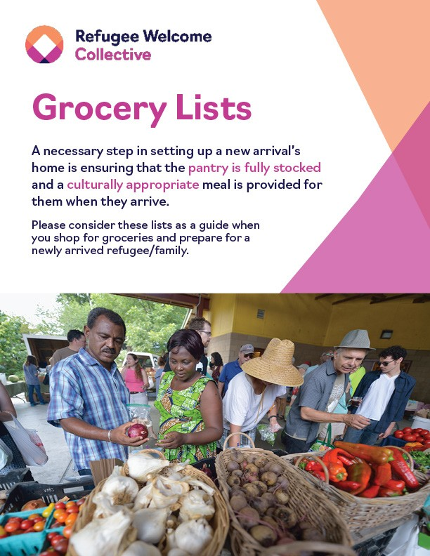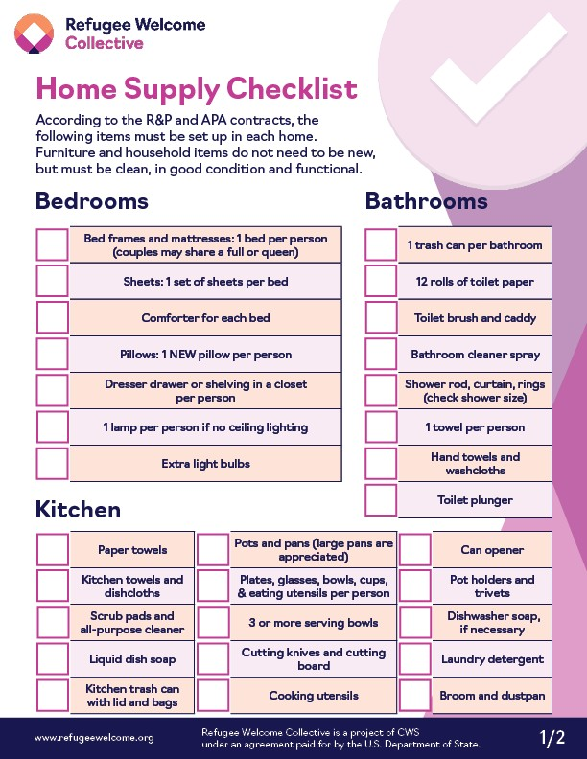

The below tools support community sponsors and newcomers in a successful start. These and other resources can be accessed through the [Refugee Welcome Collective Resource Library](http://www.refugeewelcome.org/).

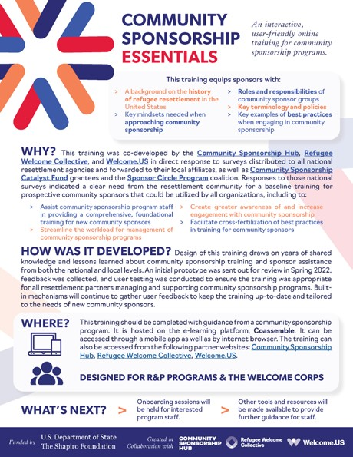

|  |
| --- |
| [**Community Sponsorship Essentials**](https://refugeewelcome.org/resources/community-sponsorship-essentials-training-one-pager/)  This one-pager provides an overview of the Community Sponsorship Essentials training course. Participants receive both in-depth information about providing resettlement services and a broad overview of how to help facilitate long-term integration and success for newcomers. |
| [**Grocery Lists**](https://refugeewelcome.org/resources/food-supply-list/)  Sponsors and volunteers are often asked to buy initial groceries and prepare a welcome meal for the family they are paired with. This document provides an overview of common foods and proposed welcome meals by country. |
| [**Home Supply Checklist**](https://refugeewelcome.org/resources/home-supply-list/)  Homes prepared for families resettled through the Reception and Placement (R&P) program need to be furnished and stocked with specific household items. This is a list of the items that must be in the home. |

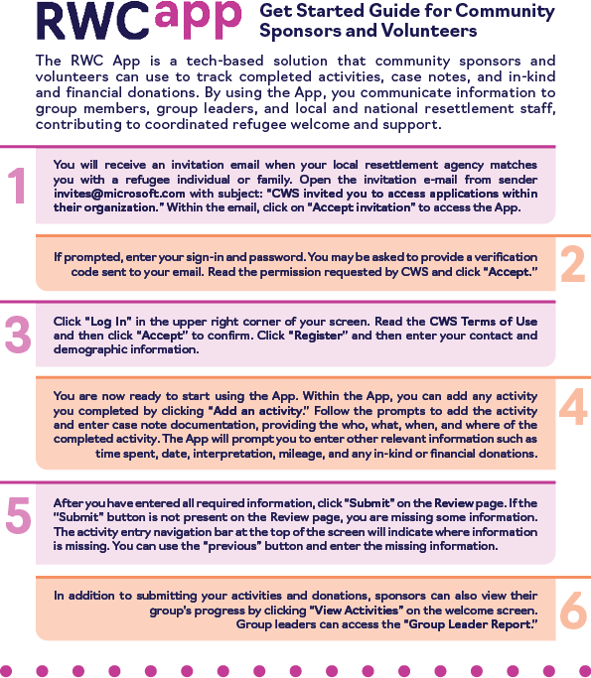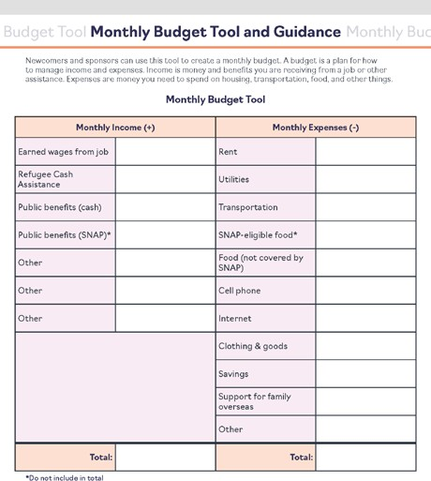

|  |
| --- |
| [**Monthly Budget Tool and Guidance**](https://refugeewelcome.org/resources/monthly-budget-tool/)  Sponsors and newcomers can use this tool to create a monthly budget. |
| [**RWC App Get Started Guide**](https://refugeewelcome.org/resources/rwc-app-get-started-guide/)  The RWC App is a tech-based solution community sponsors and volunteers can use to track activities completed, case notes, and in-kind and financial donations. For those community sponsors whose group will be using the App, the RWC App Get Started Guide helps volunteers or sponsors log in for the first time, register, and enter their volunteer or sponsor activities such as assisting with school enrollment or transportation. |
| [**Sponsorship Journey Video**](https://youtu.be/JLMt08CKDT4)  This video provides an overview of the sponsorship process and includes interviews with sponsors. |

#### 10 Resume Tips for Getting a Job in the U.S.

[usahello.org/work/find-a-job/resume-tips](https://usahello.org/work/find-a-job/resume-tips)

#### Career Coaching and Digital Resources

[upwardlyglobal.org/career-coaching](https://www.upwardlyglobal.org/career-coaching)

**Cultural Orientation Toolkit for Community Partners and Sponsors** [coresourceexchange.org/wp-content/uploads/2022/06/co-toolkit-for-community-](http://coresourceexchange.org/wp-content/uploads/2022/06/co-toolkit-for-community-partners-and-sponsors_june-2022-2.pdf) [partners-and-sponsors_june-2022-2.pdf](http://coresourceexchange.org/wp-content/uploads/2022/06/co-toolkit-for-community-partners-and-sponsors_june-2022-2.pdf)

#### Cultural Orientation Resource Exchange (CORE)

[coresourceexchange.org](https://coresourceexchange.org/)

#### Employment Authorization Documents

[switchboardta.org/wp-content/uploads/2021/02/Updated-Switchboard-Toolkit-](https://switchboardta.org/wp-content/uploads/2021/02/Updated-Switchboard-Toolkit-Work-Authorization-Documents.pdf) [Work-Authorization-Documents.pdf](https://switchboardta.org/wp-content/uploads/2021/02/Updated-Switchboard-Toolkit-Work-Authorization-Documents.pdf)

#### Mental Health Resources for Immigrants and Refugees

[usahello.org/health/mental-health/help-and-services](https://usahello.org/health/mental-health/help-and-services)

#### Grocery Lists

[refugeewelcome.org/wp-content/uploads/2022/05/grocery-list.pdf](http://refugeewelcome.org/wp-content/uploads/2022/05/grocery-list.pdf)

#### Health and Hygiene

[coresourceexchange.org/wp-content/uploads/2019/09/Health-and-Hygiene.pdf](https://coresourceexchange.org/wp-content/uploads/2019/09/Health-and-Hygiene.pdf)

#### Home Supply Checklist

[refugeewelcome.org/wp-content/uploads/2022/05/checklist_home-supply.pdf](https://refugeewelcome.org/wp-content/uploads/2022/05/checklist_home-supply.pdf)

**I am a refugee or asylee . . . How do I show my employer that I am authorized to work in the U.S.?** [uscis.gov/sites/default/files/document/guides/D2en.pdf](https://www.uscis.gov/sites/default/files/document/guides/D2en.pdf)

#### Landlord Toolkit

[refugeehousing.org/resources/landlord-toolkit](https://refugeehousing.org/resources/landlord-toolkit)

#### Monthly Budget Tool and Guidance

[refugeewelcome.org/resources/monthly-budget-tool](https://refugeewelcome.org/resources/monthly-budget-tool)

#### Public Housing Agency Contact Information

[hud.gov/program_offices/public_indian_housing/pha/contacts](https://www.hud.gov/program_offices/public_indian_housing/pha/contacts)

#### Refugee Backgrounders

[coresourceexchange.org/refugee-populations](https://coresourceexchange.org/refugee-populations)

#### Refugee Facts: Refugees in America

[unrefugees.org/refugee-facts/usa](https://www.unrefugees.org/refugee-facts/usa)

#### Refugee Housing Solutions

[refugeehousing.org](https://refugeehousing.org/)

#### How to Recruit and Retain Housing Providers Toolkit

[refugeehousing.org/resources/housing-provider-recruitment-toolkit](https://refugeehousing.org/resources/housing-provider-recruitment-toolkit)

#### Refugee Welcome Collective

[refugeewelcome.org](https://refugeewelcome.org/)

#### Refugee Welcome Collective Online Learning

[rwc-benefitsandservices.thinkific.com](https://rwc-benefitsandservices.thinkific.com/courses/rwc)

#### Resume Review Checklist

[jobversity.upwardlyglobal.org/wp-content/uploads/2018/10/Resume-Review-Checklist.pdf](https://jobversity.upwardlyglobal.org/wp-content/uploads/2018/10/Resume-Review-Checklist.pdf)

#### RWC App

[refugeewelcome.org/welcome-collective-app](http://refugeewelcome.org/welcome-collective-app)

#### SettleIn App

[settleinus.org](https://settleinus.org/)

#### State-by-State Resources for Newcomers and Sponsors

[refugeewelcome.org/state-resources](https://refugeewelcome.org/state-resources)

#### The 1951 Convention Relating to the Status of Refugees and Its 1967 Protocol

[unhcr.org/3b66c2aa10](https://www.unhcr.org/3b66c2aa10)

#### The U.S. Refugee Resettlement Program Explained

[unrefugees.org/news/the-us-refugee-resettlement-program-explained](https://www.unrefugees.org/news/the-us-refugee-resettlement-program-explained)

#### USAHello

[usahello.org](https://usahello.org/)

#### U.S. Immigration and Nationality Act Definitions

[uscis.gov/laws-and-policy/legislation/immigration-and-nationality-act](https://www.uscis.gov/laws-and-policy/legislation/immigration-and-nationality-act)

#### U.S. Refugee Admissions Program (USRAP) Flowchart

[uscis.gov/sites/default/files/document/charts/USRAP_FlowChart.pdf](https://www.uscis.gov/sites/default/files/document/charts/USRAP_FlowChart.pdf)

#### Welcome to Your New Home

[switchboardta.org/resource/welcome-new-home-illustrated-guide](https://switchboardta.org/resource/welcome-new-home-illustrated-guide/)

Select contents and expertise incorporated from Refugee Welcome Collective. Visit [refugeewelcome.org](https://refugeewelcome.org) for RWC community sponsorship resources and knowledge sharing opportunities.

Refugee Welcome Collective is a project of CWS under an agreement paid for by the U.S. Department of State.